**Demo for CouchDB on EC2**

Start couchDB:

sudo service couchdb start

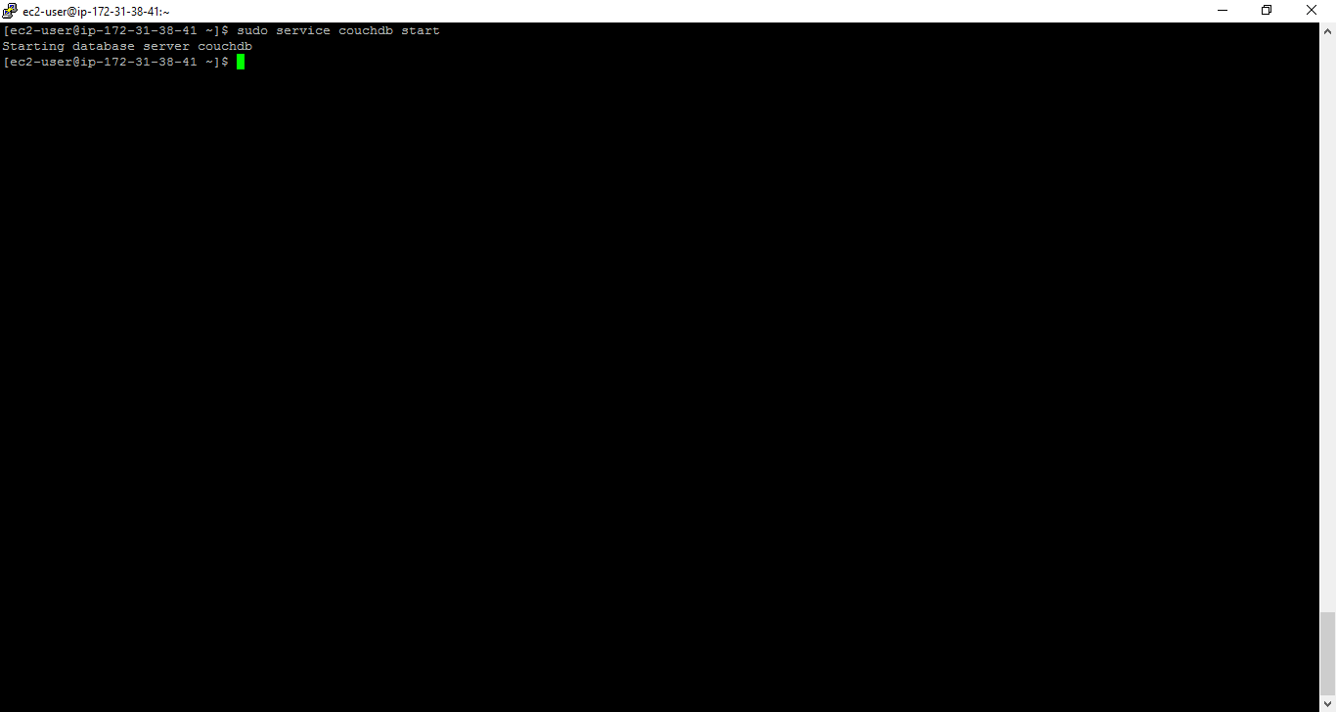

View all DBs:

curl -X GET http://127.0.0.1:5984/_all_dbs

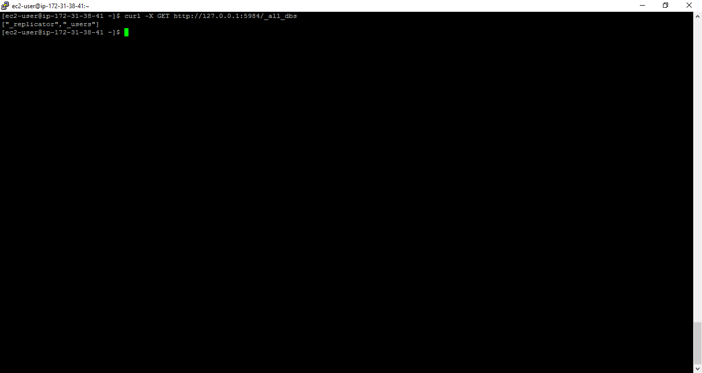

Create a DB:

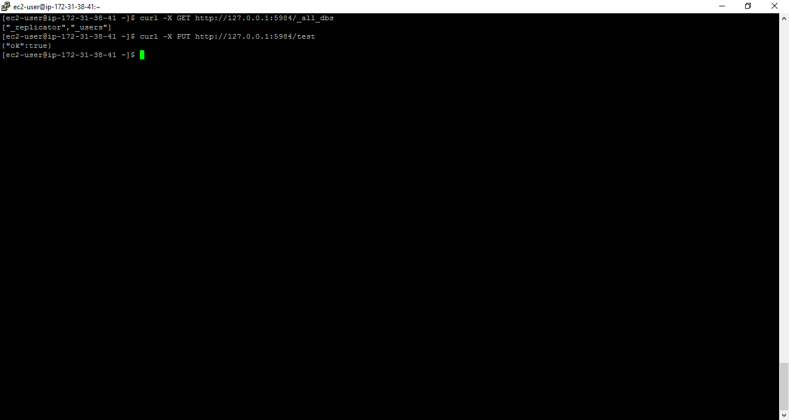

create a document:

curl -X PUT http://127.0.0.1:5984/my_database/"001" -d'{ " Name " : " Raju " , " age " :" 23 " , " Designation " : " Designer " }'

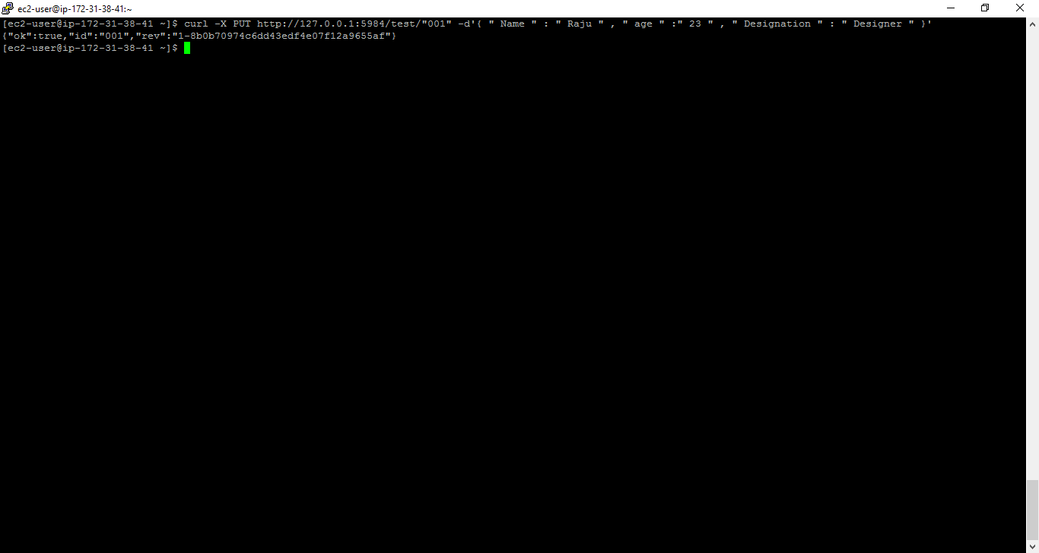

retrieve a document:

curl -X GET <http://127.0.0.1:5984/my_database/001>

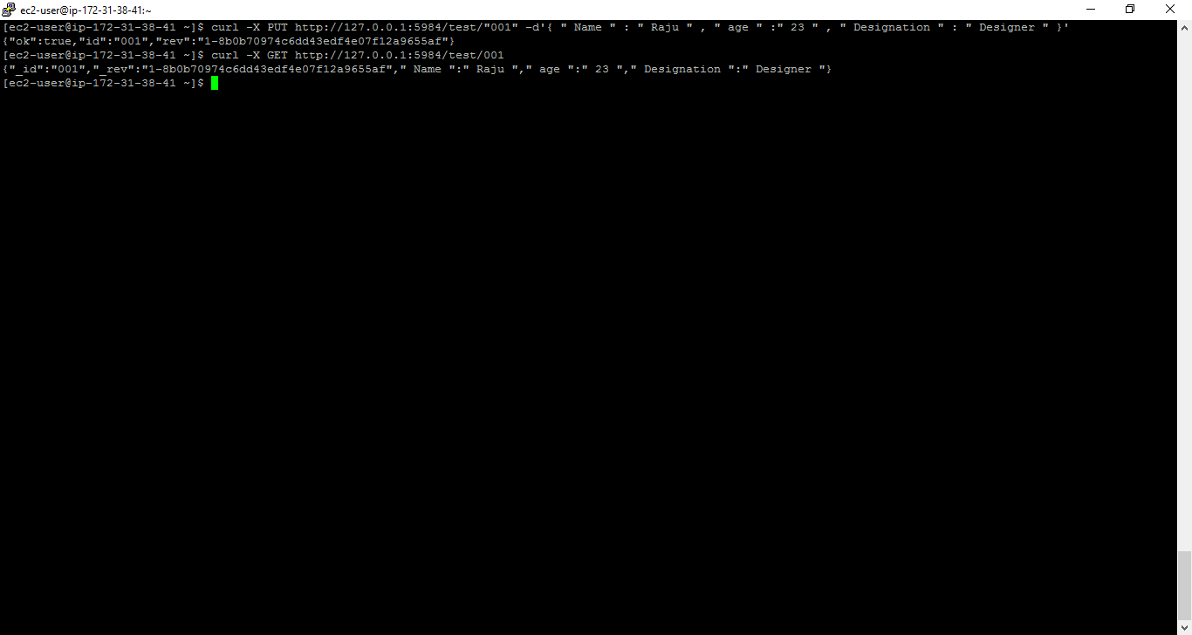

curl -X GET <http://127.0.0.1:5984/my_database/_all_docs>

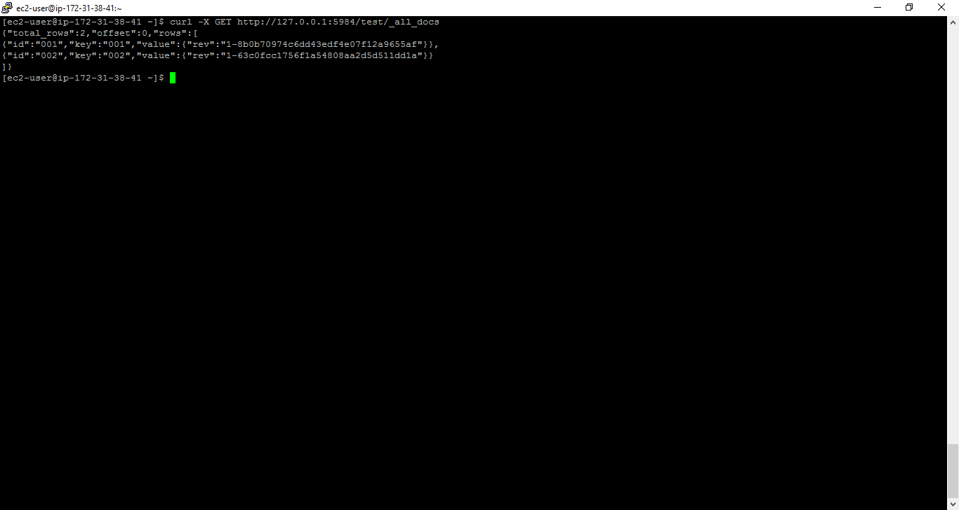

update a document:

curl -X PUT http://127.0.0.1:5984/test/001/ -d' { " age " : " 24 " , "_rev" : "1-8b0b70974c6dd43edf4e07f12a9655af" } '

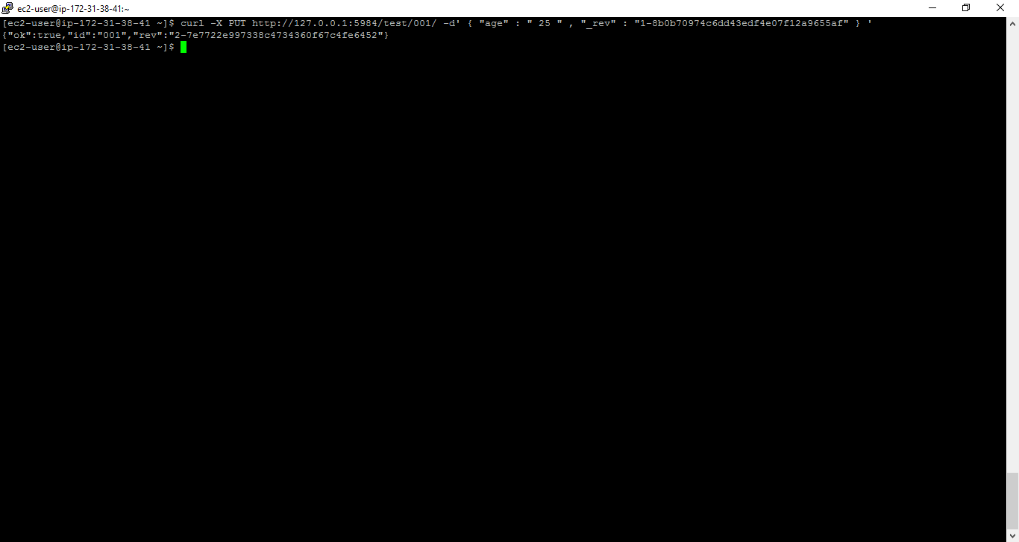

GET revision info:

curl -X GET <http://127.0.0.1:5984/my_database/001?revs_info=true>

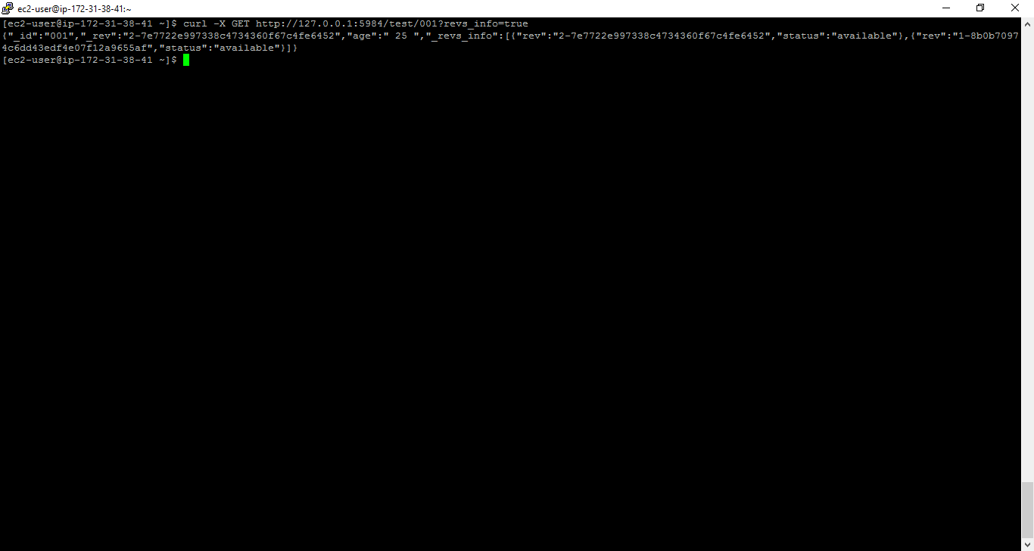

delete a document:

curl -X DELETE <http://127.0.0.1:5984/test/001?rev=1-3fcc78daac7a90803f0a5e383f4f1e1e>

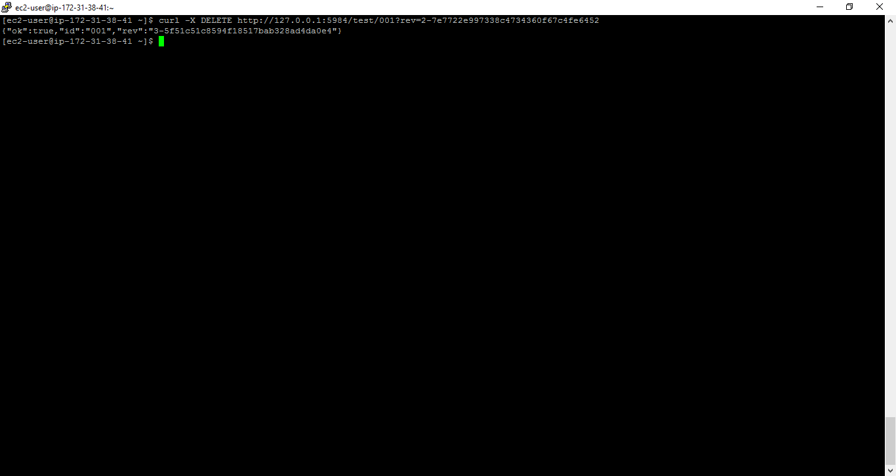

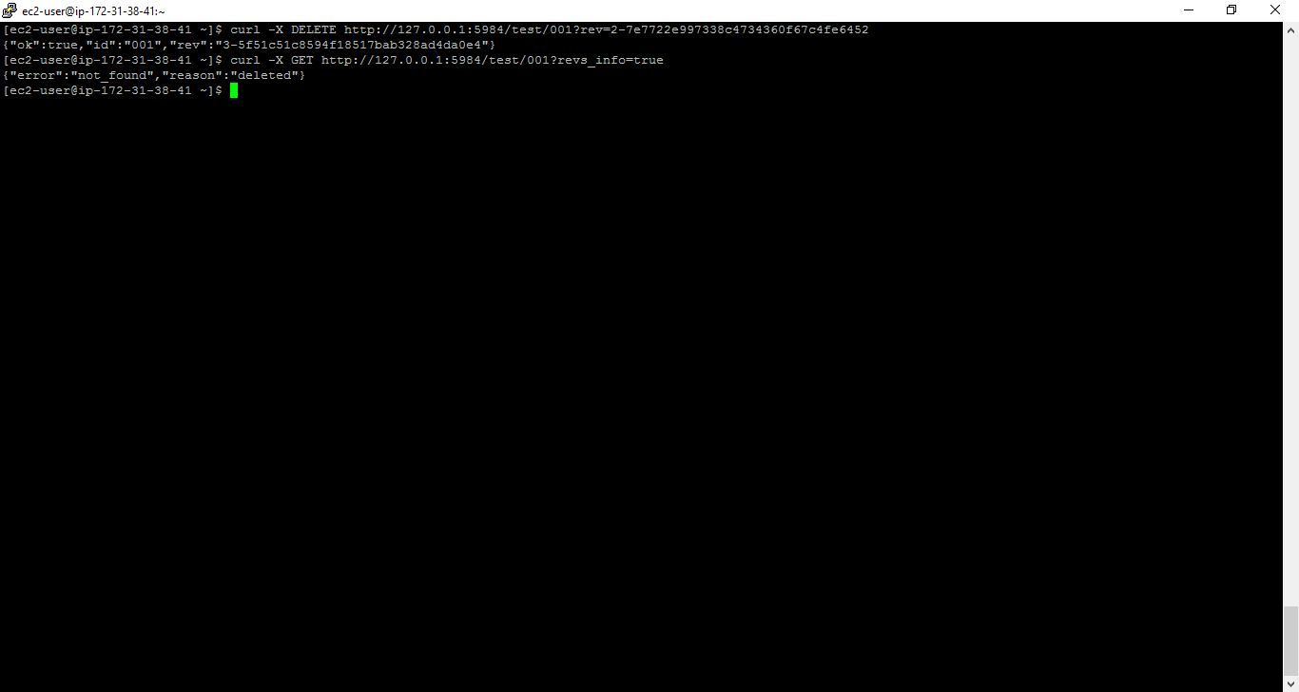

Replicate a DB:

create database test2:

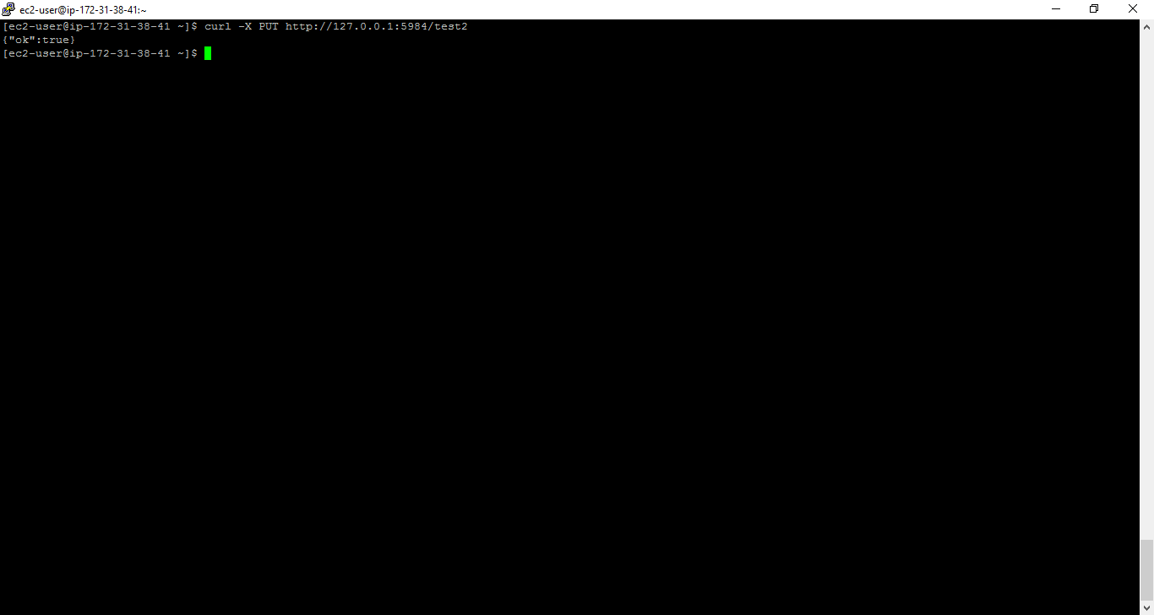

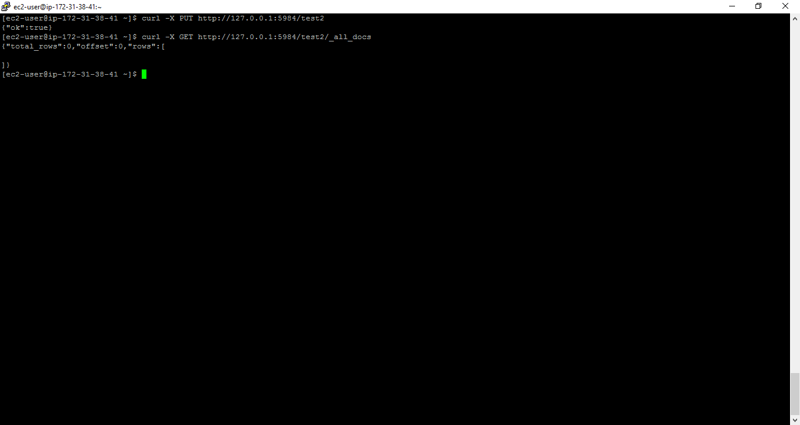

curl -H "Content-Type: application/json" -X POST http://127.0.0.1:5984/_replicate -d '{"source":"test","target":"test2"}'

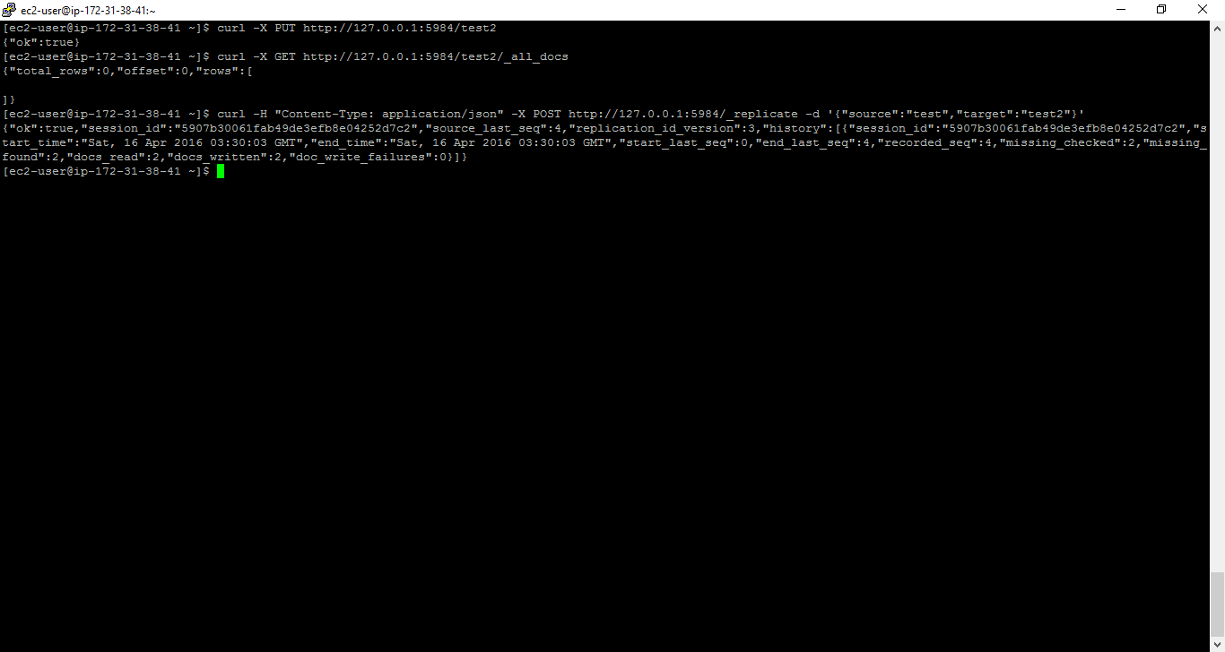

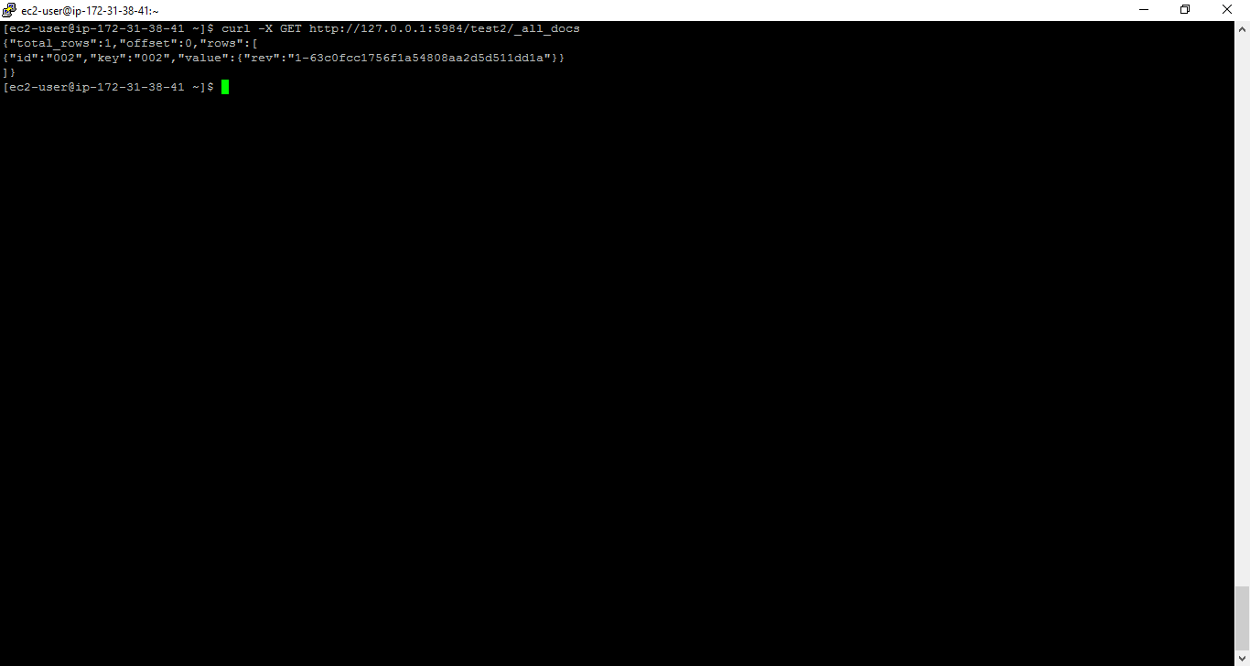

Delete a database:

